Version 1.0
01/12/2019

Alan DUFFIN
X00159409
cERTIFICATE, CLOUD SOLUTIONS ARCHITECTURE 2019, PROJECT

Implementation Phase 3.1

Table of Contents

PROJECT PLAN FOR ITERATION 3 3
PROJECT PROGRESS 4
WORKFLOW / FRONTEND INTEGRATION AND TOKEN PERSISTENCE 5
FRONT END ENHANCEMENTS 8
STEP FUNCTIONS AND CLOUDFORMATION 10
REFERENCE LIST AND BIBLIOGRAPHY 11

PROJECT PLAN FOR ITERATION 3

The table below (Table A) lists the tasks that I will attempt to complete before the final Iteration 3 deadline.

Project Phase | Service / Area | Implementation Task
Build / Development | AWS Step Functions | Extend the Step Function Workflow state machine to support Underwriting Clarification requests to the Broker to allow questions be submitted and answered regarding the mortgage application or applicant. The Broker must then be able to restart the workflow.
Build / Development | AWS Lambda | Add persistance to the Step Function tokens to allow users to restart the state machine execution from the Browser. Use either SQS or DynamoDB or both.
Build / Development | AWS S3 / Angular | Add Underwriter screens to the Front end app to allow the brokers to perform their tasks.
Build / Development | AWS S3 / Angular | Build new screens to allow underwriters to submit clarification questions and for the brokers to answer.
Build / Development | AWS Cloudformation | Integrate the deployment of the Workflow state machine into the project Cloud formation template.
Test | AWS Step Functions | Test State Transitions / Events / Human interaction
Table A.

PROJECT PROGRESS
This week I completed the following tasks:
- Add persistance to the Step Function tokens to allow users to restart the state machine execution from the Browser. Use either SQS or DynamoDB or both.
- Add Underwriter screens to the Front end app to allow the brokers to perform their tasks.
- Build new screens to allow underwriters to submit clarification questions and for the brokers to answer.
- Test State Transitions / Events / Human interaction

Please review the video (MP4) at the following URL:
https://s3-eu-west-1.amazonaws.com/appd.cloud.project/Cloud-Project-Implementation-Phase3.1-2019-12-01+11-44-04.mp4

WORKFLOW / FRONTEND INTEGRATION AND TOKEN PERSISTENCE

In order to allow Underwriters approve / reject / clarify mortgage applications from the Browser based front end there must be a persistence mechanism to map the mortgage application id to the Step Function Execution restart token. So the first task is to build a DynamoDB table. This is done with the SAM CloudFormation template. Figure 3.1.1

# STEP FUNCTION HUMAN TOKEN DYNAMO DB TABLE
StepFunctionTokenTable:
Type: AWS::DynamoDB::Table
Properties:
TableName: !Ref StepFunctionTokenTableName
AttributeDefinitions:
- AttributeName: "mortgageId"
AttributeType: "S"
KeySchema:
- AttributeName: "mortgageId"
KeyType: "HASH"
BillingMode: PAY_PER_REQUEST
Figure 3.1.1

We then need to modify the Underwriter Decision process to store the token that is issued by the Step Function waitForTaskToken function. Figure 3.1.2.

"AwaitUnderwriterDecision": {
"Type": "Task",
"Resource": "arn:aws:states:::lambda:invoke.waitForTaskToken",
"Parameters": {
"FunctionName": "${SendUnderwriterDecisionEmailArn}",
"Payload": {
"mortgage.$": "$.mortgage",
"ExecutionContext.$": "$$"
}
},
"TimeoutSeconds": 180,
"ResultPath": "$.lambdaresult",
"Next": "ProcessUnderwriterDecision"
},
Figure 3.1.2

We must modify the Lambda functions that are involved in this process.

startUnderwriterDecisionProcess.js
var dbTokenParam = {
TableName: STEP_FUNCTION_TABLE_NAME,
Item: {
'mortgageId': mortgage.mortgageId,
'stepFunctionToken': taskToken
}
};

await dynamoDB.put(dbTokenParam).promise();

underwriterDecisionPOST.js
var dbTokenParam = {
TableName: STEP_FUNCTION_TABLE_NAME,
Key: {
'mortgageId': decision.mortgageId
}
};

const tokenItem = await dynamoDB.get(dbTokenParam).promise();
await dynamoDB.delete(dbTokenParam).promise();

underwriterDecisionGET.js
const action = event.queryStringParameters.action;
const taskToken = event.queryStringParameters.taskToken;
const mortgageId = event.queryStringParameters.mortgageId;

var dbTokenParam = {
TableName: STEP_FUNCTION_TABLE_NAME,
Key: {
'mortgageId': mortgageId
}
};

const response = stepTokenUtil.restartWorkflow(mortgageId, taskToken, action);
await dynamoDB.delete(dbTokenParam).promise();

It was necessary to refactor the Step Function restart process because there are now two pathways for the Underwriters to submit a decision. When the Underwriter interacts with the State Machine execution via email the decision is submitted by embedded URLs with perform HTTP GET operations on API Gateway endpoints. Alternatively the Underwriter can submit the decision using the Browser based Angular frontend. In that scenario the decision is submitted via a HTTP POST operation.

In order to facilitate this two new Lamda Functions were creates that act as a thin wrapper layer to extract the requried data from the HTTP operations either from the HTTP POST body or the HTTP GET path variables. Both new functions then invoke common utilitity code to restart the Step Function workflow. This is found in the /workflow/utils.restartWorkflow.js source code file.

FRONT END ENHANCEMENTS
I have enhanced the front end Angular code to allow underwriters to view Mortgage Applications that require their attention. Also they can inspect the mortgage application information and approve or reject applications from within the browser web app.

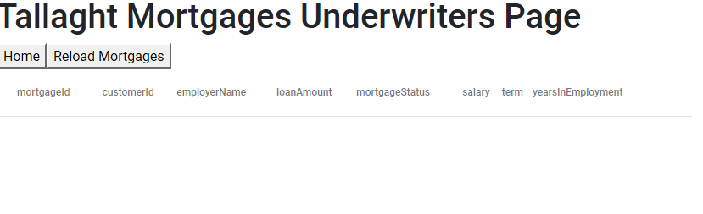
Figure 3.1.3

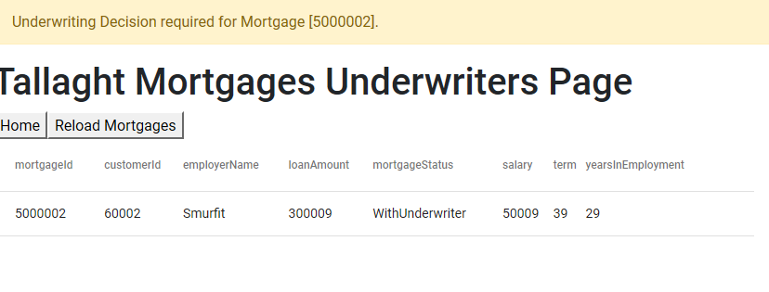
Figure 3.1.4

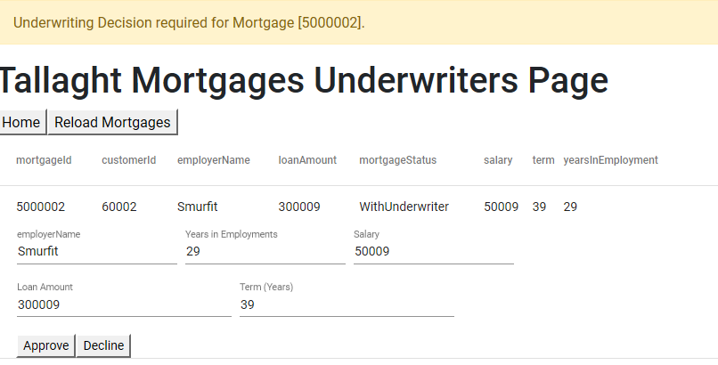
Figure 3.1.5

STEP FUNCTIONS AND CLOUDFORMATION
Integrate the deployment of the Workflow state machine into the project Cloud formation template.

Also this week I have hoped to integrate the Step Function State Machine definition into the CloudFormation stack template. However after spending 2 days investigating, numerous attempted deployments and restructuring of the template I have not been able to get this working.

To define a State Machine definition in the CloudFormation YAML template it is necessary to define a JSON definition string which is counter intuitive – to specify JSON in a YAML file.

Resources:
MortgagesStateMachine:
Type: AWS::StepFunctions::StateMachine
Properties:
StateMachineName: Tallaght-Workflow
DefinitionString:
!Sub
- |-
{
"StartAt": "GetMortgageApplication",
"States": {
"GetMortgageApplication": {
"Type": "Task",
"Resource": "${GetMorgtageFunctionArn}",
"ResultPath": "$.lambdaresult",
"Next": "GetMortgageApplicationResult"
},

The advantages of having the Step Function definition in the CloudFormation template are that we can reference the ARNs of the Lambda Functions during stack deployment. Lambda functions that need to refer to the Step Function ARN could also capture the up to date ARN in Environment variables.

However after a number of hours correctly formatting the State Machine definition in the CloudFormation template, during the deployment I received Circular Dependancy errors due to the dependancies between Lambda Functions, API Gateway and the Step Function definition. This points to a problem I have introduced somewhere. I believe the cause of this problem is the auto generation of the API Gateway Resouce operations within CloudFormation. By using the 'Event' definition on the Lambda functions to create HTTP endpoints, CloudFormation is automatically generating IAM policies/roles which may be required in some part of the definition before they are actually being created. The fix would be to explicity define the HTTP Resources in an API Gateway Resource. However then I would need to add the other Resources in one at a time to find any conflicts. This will just take too long at the moment. The other solution would be to break the Cloudformation template into smaller logically defined areas, e.g. Workflow, Lambda, Database, etc and chain the Outputs and Inputs.

However after many attempts to find a solution (that does not include building the template again from the ground up) I have to acknowledge that I do not have sufficient time. I must focus on extending the State Machine next week to include the ability to request clarifications about the mortgage applications.

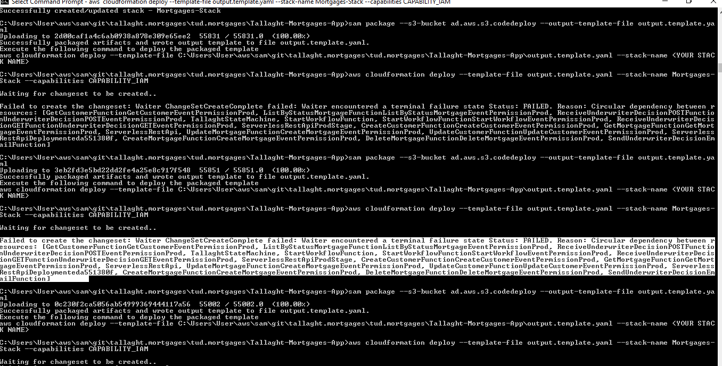
Figure 3.1.6

NEXT TASKS
My main priority this week is to implement the Clarification functionality. This will require code changes in the Step Function definition, new Lambda Functions, modifications to existing ones and Angular front end changes. So there is a significant amount of coding still remaining.
If time permits then I will revisit the Circular dependancy error that I am encountering with the CloudFormation Step Function definition.

Project Phase | Service / Area | Implementation Task
Build / Development | AWS Step Functions | Extend the Step Function Workflow state machine to support Underwriting Clarification requests to the Broker to allow questions be submitted and answered regarding the mortgage application or applicant. The Broker must then be able to restart the workflow.
Build / Development | AWS S3 / Angular | Build new screens to allow underwriters to submit clarification questions and for the brokers to answer.
Build / Development | AWS Cloudformation | Integrate the deployment of the Workflow state machine into the project Cloud formation template.
Test | AWS Step Functions | Test State Transitions / Events / Human interaction

REFERENCE LIST AND BIBLIOGRAPHY

[1] AWS Free Tier. https://aws.amazon.com/free/
[2] AWS CLI. https://docs.aws.amazon.com/cli/latest/userguide/install-windows.html
[3] AWS CLI SAM. https://docs.aws.amazon.com/serverless-application-model/latest/developerguide/serverless-sam-cli-install-windows.html
[4] Node JS. https://nodejs.org/en/download/
[5] Configure AWS CLI. https://docs.aws.amazon.com/cli/latest/userguide/cli-chap-configure.html
[6] Visual Studio Code. https://code.visualstudio.com/download
[7] Configure AWS on Visual Studio Code. https://docs.aws.amazon.com/toolkit-for-vscode/latest/userguide/setup-toolkit.html
[8] Install Docker Toolbox. https://docs.docker.com/toolbox/toolbox_install_windows/
[9] DynamoDB Cloudformation Template. https://github.com/GeneralYeager/tallaght.mortgages/blob/master/mortgage.dynamo/dynamo-create.yml
[10] Lambda Cloudformation Template. https://github.com/GeneralYeager/tallaght.mortgages/blob/master/tud.mortgages/Tallaght-Mortgages-App/template.yaml
[11] Step Function State Machine Template. https://github.com/GeneralYeager/tallaght.mortgages/blob/master/mortgage.workflow/StateMachineV3.txt
[12] https://aws.amazon.com/blogs/compute/announcing-websocket-apis-in-amazon-api-gateway/
[13] https://docs.aws.amazon.com/step-functions/latest/dg/concepts-amazon-states-language.html
[14] https://docs.aws.amazon.com/step-functions/latest/dg/concepts-input-output-filtering.html
[15] https://docs.aws.amazon.com/step-functions/latest/dg/welcome.html
[16] https://docs.aws.amazon.com/step-functions/latest/dg/connect-to-resource.html#connect-wait-token

